**CHAPTER 1**

**PATTERN RECOGNITION**

Pattern recognition is the act of taking in raw data and performing an action based on the **category** of the pattern. It is the assignment of a label to a given input value. There are practical needs to find more efficient ways of doing things but machines may perform these tasks faster, more accurately and cheaply. The goal of pattern recognition research is to clarify complicated mechanisms of decision making processes and automate these functions using computers. This chapter explains in detail about pattern recognition and its different learning techniques. Figure 1.1 shows the bit pattern example of a human face.

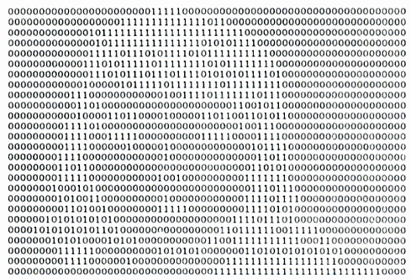

**Figure 1.1 A bit pattern representation of a human face**

**1.1 APPROACHES TO PATTERN RECOGNITION**

In pattern recognition new knowledge is phrased in terms of existing knowledge. The starting point of this process is set by generally accepted, evident views or facts that cannot be explained further. Different types of approaches may be distinguished that are caused by differences in starting points. The two approaches for the pattern recognition are as follows:

**1.1.1** **STATISTICAL APPROACH**

Statistical pattern recognition (Pierre, 1982) has been used successfully to design a number of commercial recognition systems. In statistical pattern recognition, a pattern is represented by a set of *d* features, or attributes, viewed as a *d* dimensional feature vector. Well-known concepts from statistical decision theory are utilized to establish decision boundaries between pattern classes. The recognition system is operated in two modes: training (learning) and classification (testing).

**1.1.2 SYNTACTIC APPROACH**

In many recognition problems involving complex patterns, it is more appropriate to adopt a hierarchical perspective where a pattern is viewed as being composed of simple sub patterns which are then self-built from yet simpler sub patterns. The simplest or elementary sub patterns to be recognized are called primitives and the given complex pattern is represented in terms of the interrelationships between these primitives. In syntactic pattern recognition, a formal analogy is drawn between the structures of patterns and the syntax of a language. The patterns are viewed as sentences belonging to a language, primitives are viewed as the alphabet of the language, and the sentences are generated according to a grammar. Thus, a large collection of complex patterns can be described by a small number of primitives and grammatical rules. The grammar for each pattern class must be inferred from the available training samples.

**1.2 PATTERN RECOGNITION PROCESS**

Pattern recognition has been under constant development for many years. It includes lots of methods impelling the development of numerous applications in different fields. The basic components in pattern recognition (Sholom, 1990) are preprocessing, feature extraction, and classification as shown in Figure 1.2. Once the dataset is acquired, it is preprocessed, so that it becomes suitable for subsequent sub-processes. The next step is feature extraction, in which, the dataset is converted into a set of feature vectors which are supposed to be representative of the original data. These features are used in the classification step to separate the data points into different classes based on the problem requirement.

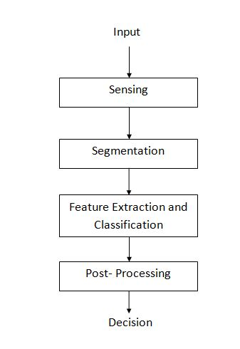

**Figure 1.2 Components of Pattern Recognition**

**1.2.1 PREPROCESSING**

Image preprocessing is a desirable step in every pattern recognition system to improve its performance. It is used to reduce variations and produce a more consistent set of data. Preprocessing should include some noise filtering, smoothing and normalization to correct the image from different errors, such as strong variations in lighting direction and intensity. Moreover, image segmentation could also be done in this step. It is typically used to locate objects and boundaries (lines, curves, etc.) in images and it is a way to change the representation of the given image into something more meaningful and easier to analyze. In some applications, segmentation of the interesting pattern of a given image from the background is very important, for example, dealing with diseases detection in agriculture applications needs segmentation of the infected region of the diseased plant images.

**1.2.2 FEATURE EXTRACTION**

Feature extraction is used to overcome the problem of high dimensionality of the input set in pattern recognition. Therefore, the input data will be transformed into a reduced representation set of features, also named feature vector. Only the relevant information from the input data should be extracted in order to perform the desired task using this reduced representation instead of the full size input. Features extracted should be easily computed, robust, rotationally invariant and insensitive to various distortions and variations in the images. Then optimal features subset than can achieve the highest accuracy results should be selected from the input space. Many methods for feature extraction exist in the literature like Principal Compound Analysis, Nonlinear Dimensionality Reduction, etc.

**1.2.3 CLASSIFICATION**

The task of the classifier component is to use the feature vector provided by the feature extractor to assign the object to a category. Because perfect classification performance is often impossible, a more general task is to determine the probability for each of the possible categories. The abstraction provided by the feature-vector representation of the input data enables the development of a largely domain-independent theory of classification. During the classification task, the system uses the features extracted in the previous stage from each of the patterns to recognize them and to associate each one to its appropriate class. One characteristic of human pattern recognition is that it involves a teacher. Similarly a machine pattern recognition system needs to be trained. A common mode of learning is to be given a collection of labelled examples, known as training data set. From the training data set, structure information is distilled and used for classifying new inputs.

**1.3** **LEARNING METHODS OF PATTERN RECOGNITION**

A method that incorporates information from the training samples in the design of a classifier employs learning. Since it is hard to guess the best classification decision for any pattern recognition problem, the great majority of the problem classification and evaluation is spent on learning. Learning refers to some form of algorithm for reducing the error on a set of training data. Training patterns are used to learn or estimate the unknown parameters of the model. A range of gradient descent algorithms that alter a classifier’s parameters in order to reduce an error measure now permeates the field of statistical pattern recognition and demands a great deal of attention. Learning comes in several general forms. Given a pattern, its recognition or classification may consist of one of the following namely Supervised Learning, Unsupervised Learning or Reinforcement Learning.

**Definition 1.1: Instance**

An instance **x** represents a specific object. The instance is often represented by a D-dimensional feature vector **x** = (x1... xD) ∈ RD, where each dimension is called a feature. The length D of the feature vector is known as the dimensionality of the feature vector. The feature representation is an abstraction of the objects. It essentially ignores all other information not represented by the features.

**Definition 1.2: Training Sample**

A training sample is a collection of instances {**x**i}i=1..n={**x**1,...,**x**n}, which acts as the input to the learning process.

**Definition 1.3: Label**

A label y is the desired prediction on an instance **x**.

**Definition 1.4: Supervised Learning**

Let the domain of instances be X, and the domain of labels be Y. Let P(**x**, y) be an (unknown) joint probability distribution on instances and labels X × Y. Given a training sample {(**x**i, yi)}i=1..n ∼ P(**x**, y), supervised learning trains a function f : X → Y in some function family F, with the goal that f (**x**) predicts the true label y on future data **x**, where (**x**, y) ∼ P(**x**, y) as well.

**Definition 1.5: Classification**

Classification is the supervised learning problem with discrete classes Y. The function f is called a classifier.

**Definition 1.6: Unsupervised Learning**

Unsupervised learning algorithms work on a training sample with n instances {**x**i}i=1..n. There is no teacher providing supervision as to how individual instances should be handled—this is the defining property of unsupervised learning.

In supervised learning, the training sample consists of pairs, each containing an instance **x** and a label y: {(**x**i, yi)}i=1..n. One can think of y as the label on **x** provided by a teacher, hence the name supervised learning. Such (instance, label) pairs are called labeled data, while instances alone without labels (as in unsupervised learning) are called unlabeled data.

**Definition 1.7: Clustering**

Clustering splits {**x**i}i=1..n into k clusters, such that instances in the same cluster are similar, and instances in different clusters are dissimilar. The number of clusters k may be specified by the user, or may be inferred from the training sample itself.

**Definition 1.8: Reinforcement Learning**

Reinforcement learning is learning what to do, how to map situations to actions so as to maximize a numerical reward signal. The learner is not told which actions to take, as in most forms of machine learning, but instead must discover which actions yield the most reward by trying them. In the most interesting and challenging cases, actions may affect not only the immediate reward but also the next situation and, through that, all subsequent rewards. These two characteristics--trial-and-error search and delayed reward--are the two most important distinguishing features of reinforcement learning.

**1.4 EVALUATION METHODS**

Evaluation is an integral part of a system design procedure. It determines the measure of performance of the designed system. Evaluation and validation methods also predict the generalization ability of the system. Evaluation is different for classification and clustering algorithm.

**1.4.1 EVALUATION IN CLASSIFICATION**

Natural performance measure for classification problems is error rate and accuracy. If the class distribution is not balanced, the classifier will be in favor of the majority class. No single measure provides the relevant information and so a use of multiple measures is usually recommended.

**CONFUSION MATRIX**

A confusion matrix contains information about actual and predicted classifications done by a classifier, as represented in Figure 1.3. An accepted positive is called a true positive (TP) and an accepted negative, a true negative (TN). Similarly, there exist false positives (FP) and false negatives (FN). False acceptance rate (FAR) describes the amount of negatives being classified as positives and false rejection rate (FRR) describes the amount of positives being classified as negatives. True positive rate (TPR) describes positives correctly classified and false positive rate (FPR) describes the negatives incorrectly classified. Let P and N denote the total positives and total negatives.

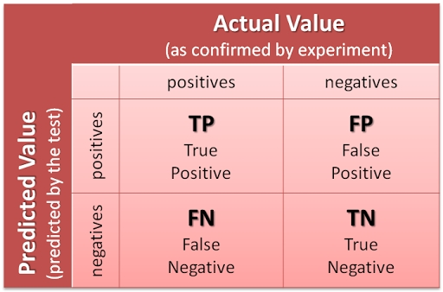

**Figure 1.3 Confusion Matrix**

Accuracy (ACC) can be computed from FAR and FRR as follows:

 (1.1)  (1.2)  (1.3)

Alternatively, using FAR and FRR

 (1.4)

 (1.5)  (1.6)

Additional terms associated are:

*Precision* =  (1.7) *Recall* = (1.8) (1.9) (1.10)  (1.11)

where FRR is the False Rejection Rate, FAR is the False Acceptance Rate, TN is True Negative, FP is False Positive, TP is True Positive, FN is False Negative, TPR is True Positive Rate and FPR False Positive Rate.

**ROC CURVE**

The ROC (Receiver Operating Characteristics) graphs are very useful for visualizing the classifier’s performance. ROC graphs are two-dimensional graphs in which TPR is plotted on the Y axis and FPR is plotted on the X axis. An ROC graph depicts relative trade-offs between benefits (true positives) and costs (false positives). Sample ROC curves are shown in Figure 1.4.

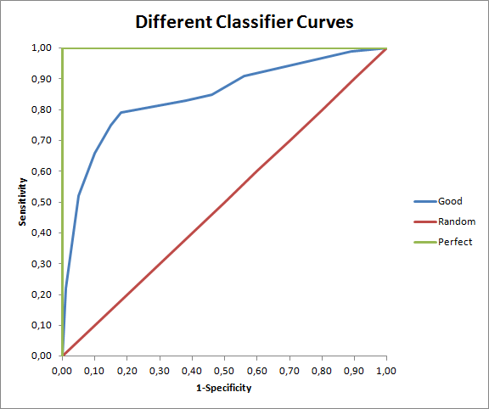

**Figure 1.4 ROC Curves**

**1.4.2 EVALUATION IN CLUSTERING**

Cluster validity provides a way of validating the quality of clustering algorithms and the means of discovering the natural structure of data sets. Furthermore, its measures are used to compare the results of different clustering algorithms, as well as two clustering results with different numbers of clusters. Cluster validity can therefore be used for determining the correct number of clusters in a data set. In fact, the clustering procedure and cluster validity have a chicken-and-egg relationship whereby knowing how to define a good clustering criterion requires an understanding of the data, but clustering is one of the principal technique used to help understand the data. The sum-of-squares-based indexes are based on sum-of-squares within cluster (SSW) or sum-of squares between clusters (SSB) values. Sum-of-squares-based indexes such as Ball and Hall, Hartigan, Calinski and Harabasz and Xu are compared.

 (1.12)

 (1.13)

 (1.14)

 (1.15)

 (1.16)

 (1.17)

where C is the data set values, m is the total number of data set values and n is the number of clusters.

**1.5 APPLICATIONS OF PATTERN RECOGNITION**

Pattern recognition finds its applications in various fields in the real world. Some examples are:

* Determine whether a given email is spam or non-spam where the incoming mail is the input value and spam and non-spam are the two different classes.
* Diagnose diseases
* Identify incoming missiles from radar or sonar signals
* Recognize faces, voice
* Identify species of flowers
* Spot an approaching storm
* Recognize optical characters

**CHAPTER 2**

**PROGRAMMING ENVIRONMENT**

This chapter describes the programming language that is used in the project and a brief description of the language and the techniques employed to understand the programming language.

**2.1 R PROGRAMMING LANGUAGE**

R is a free software programming language and software environment for statistical computing and graphics. The R language is widely used among statisticians and data miners for developing statistical software and data analysis. Polls and surveys of data miners are showing R's popularity has increased substantially in recent years.

R is an implementation of the S programming language combined with lexical scoping semantics inspired by Scheme. S was created by John Chambers while at Bell Labs. R was created by Ross Ihaka and Robert Gentleman at the University of Auckland, New Zealand, and is currently developed by the RDevelopment Core Team, of which Chambers is a member. R is named partly after the first names of the first two R authors and partly as a play on the name of S.

R is a GNU project. The source code for the R software environment is written primarily in C, FORTRAN, and R. R is freely available under the GNU General Public License, and pre-compiled binary versions are provided for various operating systems. R uses a command line interface; however, several graphical user interfaces are available for use with R.

R is an interpreted language. Users typically access it through a command-line interpreter. If a user types "2+2" at the R command prompt and presses enter, the computer replies with "4", as shown below:

2+2

[1] 4

The capabilities of R are extended through user-created packages, which allow specialized statistical techniques, graphical devices (ggplot2), import or export capabilities, reporting tools (knitr, Sweave), etc. These packages are developed primarily in R, and sometimes in Java, C and FORTRAN. A core set of packages is included with the installation of R, with more than 5,800 additional packages and 120,000 functions (as of June 2014) available at the Comprehensive R Archive Network (CRAN), Bioconductor, and other repositories.

R operates effectively on named data structures namely vectors, matrices, arrays, lists and data frames. R supports all the numeric operations, arithmetic operations, math functions, string manipulations and regular expressions.

Vector function in R is executed as,

c(10.4, 5.6, 3.1, 6.4, 21.7)

[1] 10.4 5.6 3.1 6.4 21.7

Matrix function in R is executed as,

matrix( c(2,4,3,1,5,7), nrow = 2, ncol = 3, byrow = TRUE)

[ ,1 ] [ ,2 ] [ ,3 ]

[ 1, ] 2 4 3

[ 2, ] 1 5 7

An example for list function in R is,

list(name="Fred", wife="Mary", no.children=3,child.ages=c(4,7,9))

$name

[1] “Fred”

$wife

[1] “Mary”

$no.children

[1] 3

$child.ages

[1] 4 7 9

A data frameis used for storing data tables. It is a list of vectors of equal length. For example, the following variable df is a data frame containing three vectors n, s, b.

n 🡨 c(2,3,5)

s 🡨 c(“a”, “bb”, “cc”)

b 🡨 c(TRUE, FALSE, TRUE)

df 🡨 data.frame(n, s, b)

Large data objects are easily read from external files like tables, text files, code files and excel files and it is also possible to write the output of the R program into any external file. Example for reading/writing data from/to an external file is,

initial 🡨 read.table(“database.txt”, nrows = 100)

taball 🡨 write.csv(initial,“output.txt”)

Functions are a fundamental building block in R because they are treated as an object and can work with functions in the same way one works with objects. An example for a function declaration and definition in R is,

X 🡨 10

f1 🡨 function(x) {

function() {

x + 10

} }

f1(1)()

[1] 11

**PLOTTING SYSTEM**

R provides more generic functions for plotting its objects. Many plot functions which provides lots of facilities are available like xyplot, barplot, boxplot, ggplot, matplot, scatterplot and so on. Figure 2.2 shows an example of xyplot.

To demonstrate the plotting function in R a data set was considered that contains all the police incidents (except homicide and manslaughter) that were reported in San Francisco for June, 2012. The data set contains the date, time of day, and day of week that each incident was reported, along with the incident’s category, a brief description, and location (as police district, lat-long coordinates, and address to the nearest block). To predict the likelihood of a given incident being a violent crime, as a function of time, day, and location, to define violent crimes, as assault, robbery, rape, kidnapping, and purse snatching. A month’s average rate of violent incidents (excluding homicide/manslaughter) was about 13%.

table(incidents$violent)/length(incidents$violent)

# FALSE TRUE

# 0.8733564 0.1266436

The rate of violent incidents increases significantly (relative to midnight) at about 1 am. The rate is significantly lower than at midnight around late morning and noon. The graph in Figure 2.1 shows that the rate of incidents (violent or otherwise) peaks at about 5 pm.

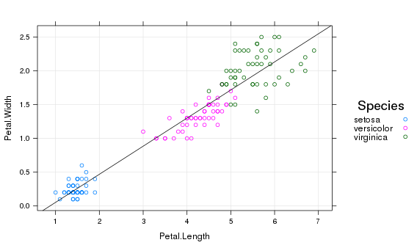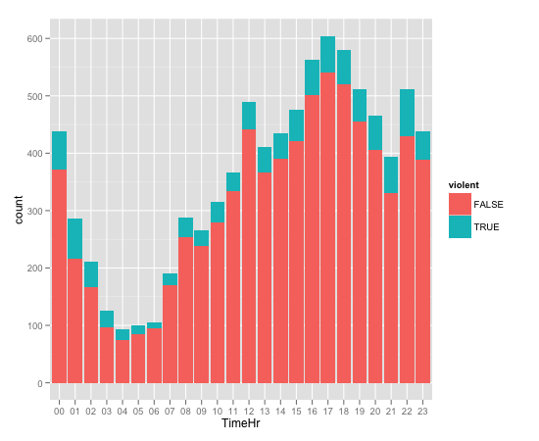

**Figure 2.2 xyplot**

**Figure 2.1 Graph for police incidents**

R has the statistical functions including mean(), median(), min(), max(), sd(), var() which can run on a 1-dimensional vector of numbers. Few function like mean() and median() won’t work on a 2-dimensional data frame. Example of a statistical function in R is,

median(c(1:3, 100, 1000))

[1] 3

R includes a few real data sets for use in testing despite of importing those data sets from an external source. The available data sets can be viewed by using the following code.

library(MASS)

data()

**2.2 IRIS DATA SET**

Iris data set is a multivariate data set introduced by Si Ronald Fisher in 1936 and is an existing dataset in R. The data set consists of 50 samples from each of the three species of Iris which consists of the four classes measured from each sample: the length and the width of the sepals and petals, in centimeters. Figure 2.3 shows a sample of Iris dataset classes. The three features of the Iris dataset are:

1) Iris setosa

2) Iris virginic

3) Iris versicolor

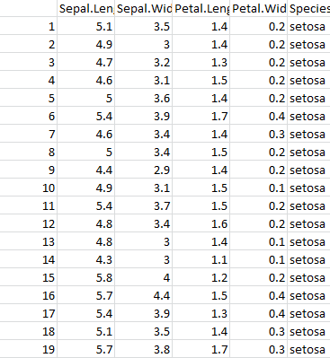

**Figure 2.3 Iris dataset Sample**

**2.3 CLASSIFICATION ALGORITHM**

K-Nearest Neighbor algorithm, a classification algorithm was implemented in R using the iris data set.

**K NEAREST NEIGHBOR ALGORITHM**

The K-Nearest Neighbors algorithm (or K-NN for short) is a [non-parametric](http://en.wikipedia.org/wiki/Non-parametric_statistics) method used for [classification](http://en.wikipedia.org/wiki/Statistical_classification). The input consists of the k closest training examples in the [feature space](http://en.wikipedia.org/wiki/Feature_space) and the output is a class membership. An object is classified by a majority vote of its neighbors, with the object being assigned to the class most common among its k nearest neighbors (k is a positive [integer](http://en.wikipedia.org/wiki/Integer), typically small). If k = 1, then the object is simply assigned to the class of that single nearest neighbor. N is a type of [instance-based learning](http://en.wikipedia.org/wiki/Instance-based_learning), or [lazy learning](http://en.wikipedia.org/wiki/Lazy_learning), where the function is only approximated locally. In Figure 2.4 k-nearest neighbor classification of the Iris dataset set using the inbuilt function kknn is performed. Among the 150 samples, 50 were used as testing samples and remaining 100 samples were treated as the training samples. For each row of the test set, the k nearest training set vectors (according to Minkowski distance) are found, and the classification is done via the maximum of summed kernel densities.

C:\Users\Abhi\Documents\R\knnn.tiff

**Figure 2.4 KNN Classification on the Iris Data Set**

**2.4 CLUSTERING ALGORITHM**

K-Means algorithm, a clustering algorithm was implemented in R using the iris data set.

**K- MEANS CLUSTERING**

K-means clustering aims to partition n observations into k clusters in which each observation belongs to the cluster with the nearest mean. This results in a partitioning of the data space into Voronoi cells.K-means clustering tends to find clusters of comparable spatial extent, while the expectation-maximization mechanism allows clusters to have different shapes.

Given a set of observations (**x**1, **x**2, …, **x***n*), where each observation is a *d*-dimensional real vector, K-means clustering aims to partition the *n* observations into k (≤ n) sets **S** = {*S*1, *S*2, …, *Sk*} so as to minimize the within-cluster sum of squares (WCSS).

C:\Users\Abhi\Documents\R\irisdataset\kmeansindexmeasures\kmeansindex.tiffC:\Users\Abhi\Desktop\kmeans.tiff

**Figure 2.5 Kmeans clustering on the Iris dataset**

**Figure 2.6 Cluster Validity Measures**

In Figure 2.5 the features of the Iris dataset namely Sepal Length and Sepal Width are grouped using the inbuilt kmeans function with cluster value being set to 3 and the output is plotted as a graph. The graph shows the concentration of samples belonging to the same feature, forming clusters in a specific region.

In Figure 2.6 the cluster validity measures using the equations (1.1) to (1.6) are computed and the values of different index measures namely Ball Index, Hartigan Index, calinski&harabasz index and Davies Bouldin index are plotted. The graph shows that the values of the index measures changes abruptly at the cluster value approximately equals to 3 which proves that the cluster value of the Iris Data Set is 3.

.

**CHAPTER 3**

**FINGERPRINT RECOGNTION**

Biometrics refers to the science and technology of measuring and analysing physical characteristics like finger print, face, Iris, hand geometry or behavioural traits like gait and voice for authentic purposes. Since biometric identifiers cannot be easily misplaced, forged or shared, they are considered more reliable than traditional (keys or password) based methods. Biometric recognition can provide better security, higher efficiency and increased user convenience. Hence a large number of government and civilian applications use this. Fingerprints are the most widely used biometric characteristics because of distinctiveness & persistence properties. Fingerprints have been used in forensics for over a century and increasing identity fraud has created a growing need for biometric technology for person recognition in a number of non-forensic applications. Fingerprint is still a complex and challenging pattern recognition problem as the designing algorithm of extracting salient features and matching them should be robust. As fingerprint gets increasingly embedded into various systems (mobile phones) it becomes increasingly important to analyse the impact of biometrics on the overall integrity of the system and its social acceptability as well as related security & privacy issues.

**3.1 FINGERPRINT REPRESENTATION**

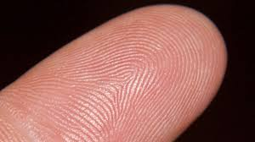

**Figure 3.1 Sample Fingerprint Image**

A fingerprint is the feature pattern of one finger. Each person has his/her own fingerprints with the permanent uniqueness. However, shown by intensive research on fingerprint recognition, fingerprints are not distinguished by their ridges and furrows, but by Minutia, which are some abnormal points on the ridges. Figure 3.1 shows an example of a sample fingerprint of a person. Singular points called loop & delta are control points, around which the ridge lines are wrapped. Singular points & coarse ridge line shape are very important for fingerprint classification and indexing. In addition, shape, orientation image & frequency image features can also be detected at global level. At local level, 150 different local ridge characteristics called minute details have been identified. Two most prominent among them are ridge termination and ridge bifurcation. A ridge ending is defined as the ridge point where a ridge ends abruptly. A ridge bifurcation is defined as the ridge point where a ridge forks or diverges into branch ridges. At the very fine level, intra-ridge details like sweat pores, whose position and shape are considered highly distinctive can be used. Figure 3.2 shows the termination and bifurcation representation of a minutia. However, extracting pores is feasible only in high-resolution fingerprint images.

A fingerprint is composed of different types of components which are stated as follows: Figure 3.3 shows the different components of a fingerprint image.

**Ridges**: The lines that flow in various patterns across fingerprints are called ‘Ridges’.

**Furrows**: The spaces between ridges are called ‘Furrows’ or ‘valleys’. It does not make contact with a surface under normal touch.

**Termination**: The point on a fingerprint that a friction ridge begins or ends without splitting into two or more continuing ridges or it is the immediate ending of a ridge, at which a ridge terminates.

**Bifurcation**: It is the point on the ridge from which two branches derive. Bifurcation is also known as ‘Ridge Branch’.

**Dots**: They are very small ridges.

**Islands**: Ridges those are slightly longer than dots, occupying a middle space between two temporarily divergent ridges.

**Ponds or lakes**: A notch protruding from a ridge.

**Bridges:** Small ridges joining two longer adjacent ridges.

**Crossover:** Two ridges which crosses each other.

**Core:** The core is the inner point, normally in the middle of the print, around which swirls, loops, arches center.

**Delta:** Deltas are the points, normally at the lower left or right hand of the fingerprint, at which a triangular series of ridges center.

Among these minutia types ‘Termination or Ridge Ending’and ‘Bifurcation’are mostly significant and have heavy usage. Figure 3.2 shows the termination and bifurcation of a fingerprint ridge.



**Figure 3.3 Components of a fingerprint image**

**Figure 3.2 Termination and bifurcation**

**FINGERPRINT PATTERNS**

The ridge flow constitutes a global pattern of the fingerprint and based on the structure of ridges the fingerprints can be categorized into three patterns i*)* Arch, ii) Loopand iii) Whorl. Figure 3.4 shows the different fingerprint patterns.

]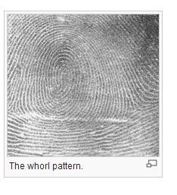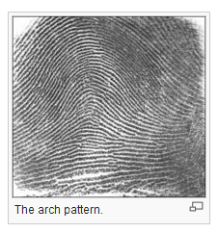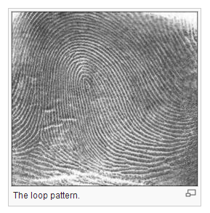

**Figure 3.4 Fingerprint Patterns**

**3.2 RECOGNITION METHODS**

The fingerprint recognition problem can be grouped into three sub-domains: fingerprint enrollment, verification and fingerprint identification. In addition, different from the manual approach for fingerprint recognition by experts, the fingerprint recognition here is referred as AFRS (Automatic Fingerprint Recognition System), which is program-based. The approaches to fingerprint matching are classified into three categories.

**3.2.1 MINUTIAE- BASED MATCHING**

This is the most popular and widely used technique, being the basis of the fingerprint comparison made by fingerprint examiners. This approach represents the fingerprint by its local features. Each Minutia may be described by a number of attributes, including its location in the fingerprint image, orientation, type (e.g., ridge termination or ridge bifurcation ), a weight based on the quality of the fingerprint image in the neighborhood of the minutia and so on. Minutia based fingerprint representation (Maio, 2003) and (Girdhar, 2008) and matching are widely used by both machine and human experts because of several advantages compared to other fingerprint representations. This technique has an advantage in helping privacy issues, since one cannot reconstruct the original image from using only minutiae information. As the minutia are predominantly randotypic in nature and cause most of the uniqueness in a fingerprint, therefore either directly or indirectly almost all fingerprint system examines minutia. But, reliably extracting minutia from poor quality fingerprints is very difficult and minutiae extraction is also time consuming. This project is based on the minutiae matching technique.

**3.2.2 CORRELATION BASED TECHNIQUE**

Let I (Δx, Δy, θ) represent a rotation of the input image I by an angle θ around the origin (usually the image center) and shifted by Δx and Δy pixels in directions x and y, respectively. Then the similarity between the two fingerprint images T and I can be measured as

 (3.1)

Where CC (T, I) = TTI is the cross-correlation between T and I.

The cross-correlation is a well-known measure of image similarity and the maximization in similarity; it allows us to find the optimal registration. The direct application of equation (3.1) rarely leads to acceptable results, mainly due to the following problems:

a) Non-linear distortion makes impressions of the same finger significantly different in terms of global structure; the use of local or block-wise correlation techniques can help to deal with this problem.

b) Skin condition and finger pressure cause image brightness, contrast, and ridge thickness to vary significantly across different impressions. The use of more sophisticated correlation measures may compensate for these problems.

c) A direct application of equation (3.1) is computationally very expensive.

**3.2.3 RIDGE FEATURE-BASED MATCHING**

The other features of the fingerprint ridge patterns e.g., local orientation and frequency, ridge shape, texture information can be extracted more reliably than minutiae but their distinctiveness is generally lower. The approaches belonging to this family compare fingerprint in terms of features extracted from the ridge pattern. In principle, correlation and minutiae-based matching could be conceived as subfamilies of ridge feature-based matching, inasmuch as the pixel intensity and the minutiae positions are themselves features of the finger ridge pattern.

**3.3 PROBLEM DEFINTION**

The uncertainties related to the complexities of the fingerprint, the lack of complete information due to loss in capture and pre-processing of an image motivated to develop an algorithm for fingerprint verification system. The scheme is modeled as a three stage process as in Figure 3.5:

Input Fingerprint 🡪 Image preprocessing 🡪 Minutiae extraction 🡪 Minutiae Matching

**Figure 3.5 Fingerprint Recognition Stages**

**3.3.1 FINGERPRINT IMAGE PREPROCESSING**

Preprocessing is required to improve the representation of the extracted features by cleaning and repairing the fingerprint. Fingerprint images undergo image enhancement, binarization and thinning.

**Image Enhancement**

The performance of minutiae extraction algorithm depends on the quality of the fingerprint images. Due to skin conditions (e.g., wet or dry, cuts, and bruises), sensor noise, incorrect finger pressure, and inherently low-quality fingers (e.g., elderly people, manual workers), a significant percentage of fingerprint images (approximately 10%) is of poor quality. There are several types of degradation associated with fingerprint images:

* The ridges are not strictly continuous. (ridges have gaps)
* Parallel ridges are not well separated. This is due to the presence of noise which links parallel ridges, resulting in their poor separation.
* Cuts, creases, and bruises on the finger.

These types of degradation make ridge extraction extremely difficult and lead to problems in minutiae extraction: (i) a significant number of spurious minutiae are extracted, (ii) a large number of genuine minutiae are missed, and (iii) large errors in the location (position and orientation) of minutiae are introduced. In order to ensure good performance of the ridge and minutiae extraction algorithms in poor quality fingerprint images, an enhancement algorithm to improve the clarity of the ridge structure is necessary.

Generally, for a given fingerprint image, the fingerprint areas resulting from the segmentation step may be divided into three categories:

* Well-defined region: ridges can be clearly differentiated from each another.
* Recoverable region: ridges are corrupted by a small amount of gaps, creases, smudges, links, and the like, but they are still visible and the neighboring regions provide sufficient information about their true structure.
* Unrecoverable region: ridges are corrupted by such a severe amount of noise and distortion that no ridges are visible and the neighboring regions do not allow them to be reconstructed.

The goal of an enhancement algorithm is to improve the clarity of the ridge structures in the recoverable regions and mark the unrecoverable regions as too noisy for further processing. Usually, the input of the enhancement algorithm is a gray-scale image. The output may either be a gray-scale or a binary image, depending on the algorithm and the goal. The fingerprint image can be enhanced by histogram equalization or fuzzy techniques.

**Binarization**

Binarization transforms a pixel value to 1 if the value is larger than the mean intensity value of the current block (16x16) to which the pixel belongs else it is 0.

**Thinning**

The binarized image needs to be thinned before the minutia can be extracted from the image. Thinning is a morphological operation that erodes the ridge pixels until they are one pixel wide. The thinning algorithm is one which follows infinite iterations till the ridge is one pixel wide. In each iteration, the neighborhood of the pixel is considered and a set of pixel-deletion criteria are applied to obtain the skeleton of the image. The requirements of a good thinning algorithm with respect to a fingerprint are

* Fingerprint image obtained should be of single pixel width with no discontinuities.
* Each ridge should be thinned to its center pixel.
* Noise and singular pixels should be eliminated.
* No further removal of pixels should be possible after completion of thinning process.

Ridge Thinning is to eliminate the redundant pixels of ridges till the ridges are just one pixel wide. There are still some locations, where the skeleton has a two-pixel width at some erroneous pixel locations. An erroneous pixel is defined as the one with more than two 4-connected neighbors. These erroneous pixels exist in the fork regions where bifurcations should be detected, but they have CN = 2 instead of CN>2. The existence of erroneous pixels may

* Destroy the integrity of spurious bridges and spurs,
* Exchange the type of minutiae points, and
* Miss detect true bifurcations,

Therefore, before minutiae extraction, there is a need to develop a validation algorithm to eliminate the erroneous pixels while preserving the skeleton connectivity at the fork regions.

**3.3.2 MINUTIAE EXTRACTION**

After the fingerprint ridge thinning, marking minutia points is the next important step. As the number of minutiae detected is more the probability of accurate result increases. The concept of Crossing Number (CN) is widely used for extracting the minutiae.

**Definition 3.1: Crossing Number**

The crossing number Cn(P) at a point P is defined as half of cumulative successive differences between pairs of adjacent pixels belonging to the 8- neighborhood of P. Rutovitz’s definition of crossing number for a pixel P is given by



(3.2)

where Pi is the binary pixel value in the neighborhood of P with Pi = (0 or 1) and P1 = P9.

It has been found that the condition most effective is

* If Cn(P) = = 1 it’s a ridge end and if Cn(P) = = 3 it’s a ridge bifurcation point. As more concentration is given on ridge endings and ridge bifurcations only, this is the best condition and there is no need to consider Cn (P) > 3 because it’s a crossing point.

**3.3.3 FALSE MINUTIAE REMOVAL**

At this stage false ridge breaks due to insufficient amount of ink & ridge cross connections due to over inking are not totally eliminated. Also some of the earlier methods introduce some spurious minutia points in the image. So to keep the recognition system consistent these false minutiae need to be removed.

**3.3.4 MINUTIAE REPRESENTATION**

Finally after extracting valid minutia points from the fingerprint they need to be stored in some form of representation common for both ridge ending and bifurcation. So each minutia is completely characterized by the following parameters 1) x-coordinate, 2) y-coordinate, 3) orientation and 4) ridge associated with it

**3.3.5 MINUTIAE MATCHING**

After successfully extracting the set of minutia points of 2 fingerprint images to be tested, minutiae matching is performed to check whether they belong to the same person or not. Given two sets of minutia of two fingerprint images, the minutiae matching algorithm determines whether the two minutiae sets are from the same finger or not.

Matching fingerprint images is a very difficult problem, mainly due to the large variability in different impressions of the same finger (i.e., large intra-class variations). The main factors responsible for intra-class variations are summarized below.

* **Displacement**: the same finger may be placed at different locations on a touch sensor during different acquisitions resulting in a (global) translation of the fingerprint area.
* **Rotation**: the same finger may be rotated at different angles with respect to the sensor surface during different acquisitions.
* **Partial overlap**: finger displacement and rotation often cause part of the fingerprint area to fall outside the sensor’s “field of view,” resulting in a smaller overlap between the foreground areas of the template and the input fingerprints.
* **Non-linear distortion**: the act of sensing maps the three-dimensional shape of a finger onto the two-dimensional surface of the sensor. This mapping results in a non-linear distortion in successive acquisitions of the same finger due to skin plasticity.
* **Pressure and skin condition**: the ridge structure of a finger would be accurately captured if ridges of the part of the finger being imaged were in uniform contact with the sensor surface.
* **Noise**: it is mainly introduced by the fingerprint sensing system; for example, residues are left over on the glass platen from the previous fingerprint capture.
* **Feature extraction errors**: the feature extraction algorithms are imperfect and often introduce measurement errors. Errors may be made during any of the feature extraction stages.

An alignment-based match algorithm is used for minutiae matching. It includes two consecutive stages: one is alignment stage and the second is match stage.

**Alignment stage**:

Given two fingerprint images to be matched, any one minutia from each image is chosen, and the similarity of the two ridges associated with the two referenced minutia points is calculated. If the similarity is larger than a threshold, each set of minutia is transformed to a new coordination system whose origin is at the referenced point and whose x-axis is coincident with the direction of the referenced point.

**Match stage:**

After obtaining two set of transformed minutia points, the elastic match algorithm is used to count the matched minutia pairs by assuming two minutia having nearly the same position and direction are identical.

The orientation of each termination (tx, ty) is estimated by following method. Track a ridge segment whose starting point is the termination and length is D. Sum up all x-coordinates of points in the ridge segment. Divide above summation with D to get sx. Then get sy using the same way.

Get the direction using the equation (3.6):

 (3.3)

**3.4 EVALUATION METHOD FOR FINGERPRINT VERIFICATION**

When a fingerprint is presented to the system for verification, a decision of the types matched / non-matched with the template already stored in the database is output. Due to imperfect sensing environment, alterations in fingers (cut, bruises etc), sensor faults, variations in the developed system, the system may output a wrong answer.

The response of the system is usually a similarity score ‘s’ that measures the similarity score between the two images (minutiae sets). The system is to output a decision based on this similarity score ‘s’. This decision is usually decided by a system with the help of threshold ‘t’: pairs of images with similarity score >= ‘t’ are called matching pairs, whereas those pairs producing score less than ‘t’ are called non-matching pairs.

A similarity score is known as a genuine score if it is a result of matching of fingerprints of the same user. It is known as an imposter score if the two compared fingerprints belong to different users. A good fingerprint matching algorithm leads to good separation between genuine scores and imposter scores.

A fingerprint verification system can make two types of errors (Maio, 2006):

• **False Match**: In this case, the system mistakes two fingerprints coming from different individuals to be a match. This is also called false acceptance. False Match Rate (FMR) is defined as the probability that an imposter scores exceeds the threshold t.

• **False Non-Match**: In this case, the system mistakes two different impressions of the same finger as a non-match. This is also called false rejection. False Non-Match Rate (FNMR) is defined as the probability that a genuine score falls below the threshold t. Figure 3.6 shows Genuine and Imposter Distributions with FNMR and FMR based on ‘t’.

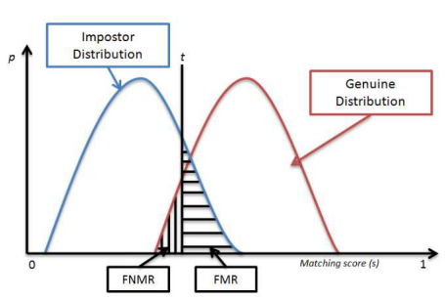

**Figure 3.6 Genuine and Imposter Distributions with FNMR and FMR based on ‘t’**

To evaluate the accuracy one must collect scores produced from a number of genuine matches (these scores form what is called the genuine distribution) and scores produced from a number of imposter matches (these scores form the imposter distribution). An example graph of FMR and FNMR over genuine and imposter distributions is shown in Figure 1.8. Both FMR and FNMR are functions of the system threshold t. If t is decreased to make the system more tolerant, the FMR increases and the FNMR decreases. If t is increased to make the system more secure, then FMR decreases and the FNMR increases. There are other measures also for measuring the system’s performance. If we plot a curve between FMR and FNMR, we obtain an important curve called receiver operating characteristic (ROC curve).

There are other metrics like:

**•Equal Error Rate (EER)**: The error rate at the threshold t where the FMR and FNMR values are identical.

**•ZeroFMR**: The lowest FNMR at which no false matches occur.  (3.4)

•**ZeroFNMR**: The lowest FMR at which no false non-matches occur.

  (3.5)

An example of curve showing FMR(t), FNMR(t) values along with the above metrics is shown in Figure 3.5.

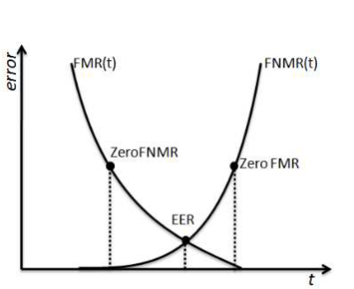

**Figure 3.5 FMR(t), FNMR(t) values along with EER(t), ZeroFMR, ZeroFNMR**

The performance of the system controlled by t is pretty much application specific. For example, some highly secure control applications like nuclear power plants etc. will need a very low FMR. In this case, t should be high as the primary objective is not to let in any imposters. Some legitimate users may be denied access in this case but that is a trade-off to accept.

**CHAPTER-4**

**IMPLEMENTATION OF FINGERPRINT RECOGNITION**

This chapter outlines the experiments conducted on the various fingerprint recognition stages, the proposed system design, implementation of the system and the dataset used, followed by the experimental results and related discussion.

**4.1 SYSTEM DESIGN**

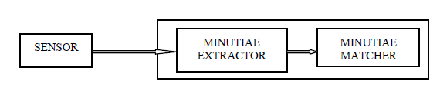A fingerprint recognition system constitutes of Fingerprint acquiring device for generating digital image of fingerprint, Minutia Extractor and Minutia Matcher (Figure 4.1) in which the Minutiae Extractor and Minutia Matcher are done in this project.

**Figure 4.1 Fingerprint Recognition Stages**

In order to get a high quality image for minutiae extractor, the enhancement techniques like histogram equalization and Fuzzification are carried out which are detailed below.

**HISTOGRAM EQUALIZATION**

The histogram of a digital image with gray levels in the range [0, L -1] is a discrete function.

 (4.1)

where  is the k’th gray level*,*  is the number of pixels in the image with that gray level, n is the total number of pixels in the image, k = 0,1,2,….,L-1 and L is equal to 256.

The equation (4.1) gives an estimate of the probability of occurrence of gray level .

**FUZZIFICATION**

The gray level of the image pixel x, gr(x) is fuzzified as,



(4.2)

where is the pixel matrix of the image, mn is the minimum value of the pixel matrix and mx is the maximum value of the pixel matrix.

The fuzzy gray level is contrast intensified by applying the INT operator (Pal &King) as follows:

 (4.3)

This transformation function is applied thrice successively, to reduce the fuzziness of the image by decreasing the fuzzy values below 0.5 and increasing the fuzzy values above 0.5. Further, the contrast intensified fuzzy gray level of each pixel x is defuzzified back to enhanced gray level by the inverse transformation.

 (4.4)

**BINARIZATION**

The binarization technique as explained in 3.5.1 is carried out experimentally.

**THINNING**

Fast thinning algorithm (Hastings, 1992) is a multi-iterative thinning algorithm which eliminates boundary points successively. Suppose target points (ridge line) are marked as 1, and background points (valley line) are marked as 0. The boundary points are iteratively operated as explained below.

**Step 1**: Set the center point as P and the eight neighborhood points clockwise around P as P1, P2, ..., P8 as shown in Figure 4.2. If the following four conditions are satisfied at the same time, point P is deleted.

(a) 2≤N(P)≥6 (b) S(P)=l (c) P1•P3•P5=0 (d) P3•P5•P7=0

where N (P) is the number of the non-zero points around P and S (P) is the frequency of changes from 1 to 0 according to the sequence of P1, P2... P8, P1.All the points that satisfy the conditions above are marked and deleted when all boundary points are checked.

**Step 2**: It is same to the first one, except that the condition (c) and (d) are changed as:

(c)P1•P3•P7=0 (d) P1•P5•P7=0

Several iterations should be performed until there is no point meeting these conditions. The ridge's skeleton is made up of the left points.

After undergoing the thinning stage, enhanced thinning is carried out.

**Enhanced Thinning**

**Step 1:** Scanning the skeleton of fingerprint image row by row from top-left to bottom-right. Check if the pixel is 1.

**Step 2:** Count its four connected neighbors.

**Step 3:** If the sum is greater that two, mark it as an erroneous pixel.

**Step 4:** Remove the erroneous pixel.

**Step 5:** Repeat steps 1 – 4 until whole of the image is scanned and the erroneous pixels are removed.

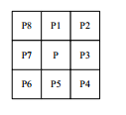

**Figure 4.2 3X3 matrix of the pixel value**

Once after the enhanced thinning is performed thorough thinning is carried on.

**Step 1:** The two ridge points as in Figure 4.3, P1 and P2, are jointed together around the objective point P.

**Step 2:** First considering point P1, ridge line can extend to the direction of q16, q1, and q2. These three points are checked in order to judge whether there is at least one point in ridge line or not.

**Step 3:** If yes, P1 is retained. Otherwise, it means that the ridge line does not extend to this direction and P1 is removed.

**Step 4:** Then considering point P2, ridge line can extend to the direction of q1, q2, q3, q4, and q5. Since q1 and q2 have already been checked, only three points q3, q4, q5 should be checked.

**Step 5:** For the case that odd-number point (P1, P3, P5 or P7) and its adjacent point are ridge-line points, the three points of outside row or column should be judged.

**Step 6:** But for the even-number point (P2, P4, P6 or P8) in the four corners, it needs to select the judged points according to the position of adjacent point.

**Step 7:** When P2 and P1 are ridge-line points, select q3, q4 and q5 to judge P2 but when P2 and P3 are ridge-line points, q1, q2 and q3 are selected.

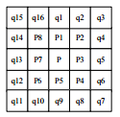

**Figure 4.3: 5×5 Template Matrix**

**MINUTIAE EXTRACTION**

The minutiae extraction is carried out using the equation (3.2) and then the Square-based method presented in (Gamassi et al., 2005) and (Alibeigi et al., 2009) was used to extract the true minutiae. The Square-based method is composed of the following steps, repeated for each pixel of the binary image:

* Create a square perimeter P around the (x, y) pixel of size W×W as in Figure 4.4.
* Compute the number of the logic commutations present in the perimeter P without considering isolated pixels.
* The process continues if there are two logic commutations, otherwise it jumps to step 1 processing another pixel.
* Compute the average of the pixels in the perimeter P. If the pixel has been defined as termination minutiae in step 1, it checks if the average is greater than the threshold K. (in bifurcation minutiae, the average must be less than 1-K) otherwise it jumps to step 1 processing another pixel.

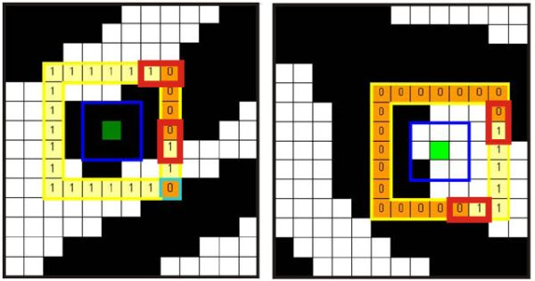

**Figure 4.4 Square based method**

**FALSE MINUTIAE REMOVAL**

The false minutiae points are removed by considering the following theoretical aspects. Figure 4.5 shows the seven different types of false minutia points.



**Figure 4.5 Different types of false minutiae identifications**

First calculate the inter ridge distance D which is the average distance between two neighboring ridges. For this scan each row to calculate the inter ridge distance using the formula:

 (4.5)

Finally an averaged value over all rows gives D.

Now the false minutia points (Figure 3.7) are removed using the following steps:

* If d (bifurcation, termination) < D & the 2 minutia are in the same ridge then remove both of them (case m1)
* If d (bifurcation, bifurcation) < D & the 2 minutia are in the same ridge them remove both of them (case m2, m3)
* If d (termination, termination) ≈ D & the their directions are coincident with a small angle variation & no any other termination is located between the two terminations then remove both of them (case m4, m5, m6)
* If d (termination, termination) < D & the 2 minutia are in the same ridge then remove both of them (case m7)

where d (X, Y) is the distance between 2 minutia points.

**MINUTIAE MATCHING**

The minutiae matching stage is carried out by the following steps.

**Minutiae Alignment**

Let I1 & I2 be the two minutiae sets given by,





Now choose one minutia from each set to find the ridge correlation factor between them. The ridge associated with each minutia is represented as a series of x-coordinates (x1, x2…xn) of the points on the ridge. A point is sampled per ridge length L starting from the minutia point, where the L is the average inter-ridge length. And n is set to 10 unless the total ridge length is less than 10*L.

**Step 1:** The similarity of correlating the two ridges is derived from equation (4.6):

 (4.6)

Where (xi..xn) and (Xi..Xn) are the set of x-coordinates for each of the 2 minutia chosen and m is minimal one of the n and N value. If the similarity score is larger than 0.8, then go to step 2, otherwise continue to match the next pair of ridges.

**Step 2:** The approach is to transform each set according to its own reference minutia and then do match in a unified x-y coordinate. Let M ( , , ) be reference minutia found from step 1(say from I1). For each fingerprint, translate and rotate all other minutiae ( , , ) with respect to M according to equation(4.6).

 (4.7)

The new coordinate system is originated at reference minutia M and the new x-axis is coincident with the direction of minutia M. No scaling effect is taken into account by assuming two fingerprints from the same finger have nearly the same size. So extract the transformed sets of minutiae I1’ & I2’.

**Minutiae Match**

An elastic string match algorithm is used to find number of matched minutia pairs among I1’ & I2’. According to the elastic string match algorithm minutia  in I1’ and a minutia  in I2’ are considered **matching** if the spatial distance (sd) (equation (4.7)) between them is smaller than a given tolerance r0 and the direction difference (dd) (equation (4.8)) between them is smaller than an angular tolerance.

 (4.7)

 (4.8)

Let mm equation (4.9) be an indicator function that returns 1 in the case where the minutiae  and  match according to above equations (4.7) and (4.8).

 (4.9)

Now the total number of matched minutiae pair given by equation (4.10),

num(matched minutiae) =  (4.10)

and final match score is given by equation (4.11),

Match Score = $num(matched minutiae)⁄max⁡(num of minutiae I1,I2)$ (4.11)

The matching score of the matched images produced a value between 1 to 2 and the unmatched images produced a value less than 1.

**4.2 REAL WORLD DATASET**

FVC 2002 Database was considered for the fingerprint recognition system. Four databases constitute the FVC2002 benchmark. Three different scanners and the SFinGE synthetic generator were used to collect fingerprints (Table 4.1).

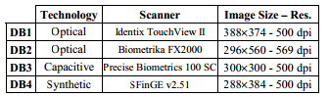

**Table 4.1 Scanners/Technologies used for the collection of FVC 2002 databases**

A total of ninety students (20 years old on the average) enrolled in the first two years of the Computer Science degree program at the University of Bologna kindly agreed to act as volunteers for providing fingerprints. In this study DB1 database was taken into study which consisted of DB1_A which is the training dataset consisting of eight fingerprint instances of 100 different fingers and DB1_B which is the testing data set consisting of eight fingerprint instances of 40 distinguishing fingers.

**4.3 RESULTS AND PERFORMANCE EVALUATION**

C:\Users\Abhi\Desktop\hist1.tiffC:\Users\Abhi\Desktop\original.tiffThe above mentioned system design stages were applied on the training database DB1_A. The output of a single instance of the fingerprint image corresponding to one finger which was made to undergo the enhancement steps is shown below. Figure 4.6 to 4.10.

C:\Users\Abhi\Desktop\binarize1.tiffC:\Users\Abhi\Desktop\fuzzy1.tiff

**Figure 4.9 Binarized image**

**Figure 4.8 Fuzzified image**

**Figure 4.6 Original image**

**Figure 4.7 Histogram equalized image**

C:\Users\Abhi\Desktop\thin1.tiff

**Figure 4.10 Thinned image**

Two indexes are well accepted to determine the performance of a fingerprint recognition system:

**False Rejection Rate**

The False Rejection Rate (FRR) is calculated using the equation (4.12)

 (4.12)

where is the imposter matching score, t is the threshold value which varies from 0.1 to 1 and NIRA is the Number of Genuine Recognition Attempts.

**False Acceptance Rate**

The False Acceptance Rate (FAR) is calculated using the equation (4.13)

 (4.13)

Where is the genuine matching score, t is the threshold value varying between 0.1 to 1.0, NGRA is the Number of Imposter Recognition Attempts and rej (NGRA) is the number of failed attempts in matching.

The average FRR and FAR values for the DB1_A database with the threshold value varying between 0.1 and 1.0 was found to be 0.14 and 0.25.

**CHAPTER 5**

**CONCLUSION**

Fingerprints are one of many forms of biometrics used to identify an individual and verify their identity. This study is an effort to understand how Fingerprint Recognition is used as a form of biometric to recognize identities of human beings. It includes all the stages from minutiae extraction of fingerprints to minutiae matching which generates a match score. Various standard techniques are used in the intermediate stages of processing. The relatively low percentage of FMR and FAR rate shows that the algorithm is much faster and produces an optimized result. Also a major challenge in Fingerprint recognition lies in the preprocessing of the bad quality of fingerprint images which also add to the low verification rate. A set of reliable techniques have implemented for fingerprint image enhancement and minutiae extraction. These techniques can then be used to facilitate the further study of the statistics of fingerprints. The future work is to enhance the study using new enhancement techniques and to introduce reinforcement learning agents into the minutiae extraction stage and try to arrive at a better result.

**BIBLIOGRAPHY**

1. Devijver, Pierre A., and Josef Kittler. Pattern recognition*:* A statistical approach. Vol. 761. London: Prentice-Hall, 1982.
2. Weiss, Sholom M., and Ioannis Kapouleas. "An empirical comparison of pattern recognition, neural nets and machine learning classification methods."Readings in machine learning (1990): 177-183.
3. Cappelli, Raffaele, Dario Maio, Davide Maltoni, James L. Wayman, and Anil K. Jain. "Performance evaluation of fingerprint verification systems." Pattern Analysis and Machine Intelligence, IEEE Transactions on 28, no. 1 (2006): 3-18.
4. D. Maltoni, D. Maio, and A. Jain, S. Prabhakar, “4.3: Minutiae-based Methods’ (extract) from Handbook of Fingerprint Recognition”, Springer, New York, pp. 141-144, 2003.
5. Kaur, Manvjeet, Mukhwinder Singh, Akshay Girdhar, and Parvinder S. Sandhu. "Fingerprint verification system using minutiae extraction technique." World Academy of Science, Engineering and Technology 46 (2008): 497-502.
6. E. Hastings, “A Survey of Thinning Methodologies”, Pattern analysis and Machine Intelligence, IEEE Transactions, vol. 4, Issue 9, pp. 869-885, 1992.
7. L. Lam, S. W. Lee, and C. Y. Suen, “Thinning Methodologies-A Comprehensive Survey”, IEEE Transactions on Pattern analysis and machine intelligence, vol. 14, no. 9, 1992.
8. Maio, Dario, Davide Maltoni, Raffaele Cappelli, James L. Wayman, and Anil K. Jain. "FVC2002: Second fingerprint verification competition." In Pattern Recognition*,* 2002. Proceedings. 16th International Conference on, vol. 3, pp. 811-814. IEEE, 2002.
9. Cappelli, Raffaele, Dario Maio, Davide Maltoni, James L. Wayman, and Anil K. Jain. "Performance evaluation of fingerprint verification systems." Pattern Analysis and Machine Intelligence, IEEE Transactions on 28, no. 1 (2006): 3-18.